Star-Bus Topology

What Is Star-Bus Topology?
# Source: AI Source: Provided by: [Data Path: Persons Table -> ID Column: 1, Name_En Column: Motasem Essam] -> From: [ChatGPT] on [12/18/2025]
A Star-Bus Topology is a type of hybrid network topology that combines the features of both Star and Bus topologies. It’s commonly used in large networks where multiple star-configured segments are connected using a single shared backbone cable — like a bus.

🧠 Simple Definition:
# Source: AI Source: Provided by: [Data Path: Persons Table -> ID Column: 1, Name_En Column: Motasem Essam] -> From: [ChatGPT] on [12/18/2025]
In Star-Bus topology, multiple star topologies are linked together by a central bus (backbone). Devices within each star connect to a switch or hub, and all hubs are connected by the bus.

🖼️ Visual Example:
# Source: AI Source: Provided by: [Data Path: Persons Table -> ID Column: 1, Name_En Column: Motasem Essam] -> From: [ChatGPT] on [12/18/2025]
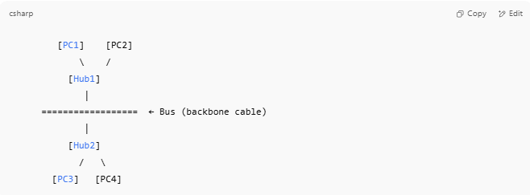

[PC1] [PC2]
\ /
[Hub1]
│
================== ← Bus (backbone cable)
│
[Hub2]
/ \
[PC3] [PC4]

- Each group of devices forms a star.
- The central bus connects the star segments together.

🔧 How It Works
# Source: AI Source: Provided by: [Data Path: Persons Table -> ID Column: 1, Name_En Column: Motasem Essam] -> From: [ChatGPT] on [12/18/2025]
- Devices communicate locally within their star via the hub or switch.
- Data destined for another star travels over the bus backbone to reach the correct hub.

✅ Advantages
# Source: AI Source: Provided by: [Data Path: Persons Table -> ID Column: 1, Name_En Column: Motasem Essam] -> From: [ChatGPT] on [12/18/2025]
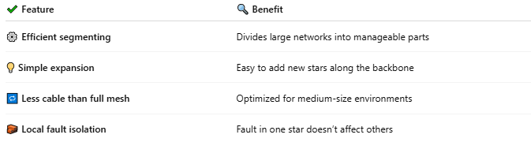

✔ Feature | 🔍 Benefit
⚙️ Efficient segmenting | Divides large networks into manageable parts
💡 Simple expansion | Easy to add new stars along the backbone
🔁 Less cable than full mesh | Optimized for medium-size environments
🧱 Local fault isolation | Fault in one star doesn’t affect others

❌ Disadvantages
# Source: AI Source: Provided by: [Data Path: Persons Table -> ID Column: 1, Name_En Column: Motasem Essam] -> From: [ChatGPT] on [12/18/2025]
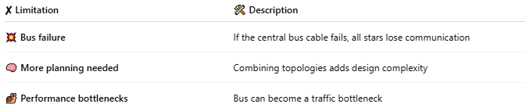

✘ Limitation | 🛠 Description
💥 Bus failure | If the central bus cable fails, all stars lose communication
🧠 More planning needed | Combining topologies adds design complexity
🐌 Performance bottlenecks | Bus can become a traffic bottleneck

🏢 Use Cases
# Source: AI Source: Provided by: [Data Path: Persons Table -> ID Column: 1, Name_En Column: Motasem Essam] -> From: [ChatGPT] on [12/18/2025]
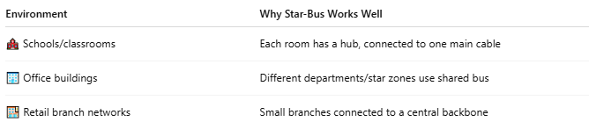

Environment | Why Star-Bus Works Well
🏫 Schools/classrooms | Each room has a hub, connected to one main cable
🏢 Office buildings | Different departments/star zones use shared bus
🏬 Retail branch networks | Small branches connected to a central backbone

✅ Summary
# Source: AI Source: Provided by: [Data Path: Persons Table -> ID Column: 1, Name_En Column: Motasem Essam] -> From: [ChatGPT] on [12/18/2025]
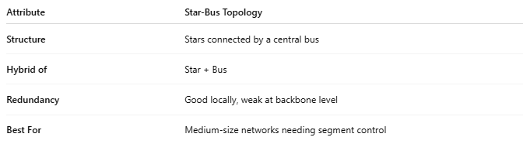

Attribute | Star-Bus Topology
Structure | Stars connected by a central bus
Hybrid of | Star + Bus
Redundancy | Good locally, weak at backbone level
Best For | Medium-size networks needing segment control

